Topic 4: Complete Setup Instructions (Enterprise Deployment Grade)
This document provides a fully detailed, enterprise-level setup guide for configuring, installing,
and deploying the system across different environments (Development, Staging, Production).
The steps follow industry best practices and ensure that the application is installed with
maximum stability, security, and performance.
The setup manual is crafted for Fortune-100 engineering standards, making the onboarding process
clear, repeatable, and suitable for large-scale development teams.
---
## 1. Prerequisites (System Requirements)
Before installation, ensure the following software and tools are available:
• Node.js (v18 or later)
• MongoDB (local or MongoDB Atlas)
• Git (latest stable version)
• NPM or Yarn package manager
• VS Code or any modern IDE
• Postman / Thunder Client for API testing
• Docker Desktop (optional but recommended)
Recommended System Specs:
• CPU: Quad-core or higher
• RAM: 8–16GB
• Storage: SSD 20GB+
• OS: Windows 10/11, macOS, or Ubuntu
These ensure smooth local development and efficient testing.
---
## 2. Clone the Repository
Use the following command to fetch the full project:
```
git clone https://github.com/rolex132/DOC_BOOK.git
```
Navigate into the project:
```
cd DOC_BOOK
```
---
## 3. Install Dependencies
Navigate into each module and install required packages.
### Install Frontend Dependencies:
```
cd client
npm install
```
### Install Backend Dependencies:
```
cd server
npm install
```
This step prepares the environment with all required libraries and frameworks.
---
## 4. Configure Environment Variables
Create a `.env` file inside the **server** folder with:
```
PORT=5000
MONGO_URI=your_mongo_connection_string
JWT_SECRET=your_secret_key
CLOUD_ENV=development
```
Additional advanced production variables:
```
LOG_LEVEL=verbose
TOKEN_EXPIRY=7d
REFRESH_TOKEN_EXPIRY=30d
CORS_ORIGIN=https://your-frontend-url.com
```
These ensure secure authentication, logging, and scalability.
---
## 5. Start the Application (Local Environment)
To start the backend server:
```
cd server
npm start
```
To start the frontend:
```
cd client
npm start
```
The project will run at:
• Frontend: http://localhost:3000
• Backend: http://localhost:5000
Both services communicate seamlessly using REST APIs.
---
## 6. Database Setup (MongoDB)
For **local MongoDB**:
• Install MongoDB Community Server
• Start MongoDB service
• Create a database named `bookStoreDB`
For **MongoDB Atlas**:
• Create a cluster
• Whitelist IP 0.0.0.0
• Generate connection URI
• Paste it into `.env` → `MONGO_URI`
MongoDB is optimized for horizontal scaling and production indexing.
---
## 7. Build Process (For Deployment)
Before deploying to any cloud provider, build the frontend:
```
cd client
npm run build
```
This generates a production-optimized version with:
• Minified assets
• Performance enhancements
• Code splitting
• Tree-shaking
---
## 8. Deployment Workflow
Recommended Deployment Platforms:
• Vercel (Frontend)
• Netlify (Frontend)
• Render (Backend)
• Railway (Backend)
• AWS / GCP / Azure (Enterprise Deployment)
• Docker + Kubernetes (High-Scale Production)
Typical production pipeline:
1. Build frontend
2. Deploy static files
3. Deploy backend container
4. Connect to MongoDB Atlas
5. Configure environment variables
6. Enable monitoring and logging tools
---
## 9. Setup Workflow Diagram
Below is a visual diagram of the complete setup workflow:
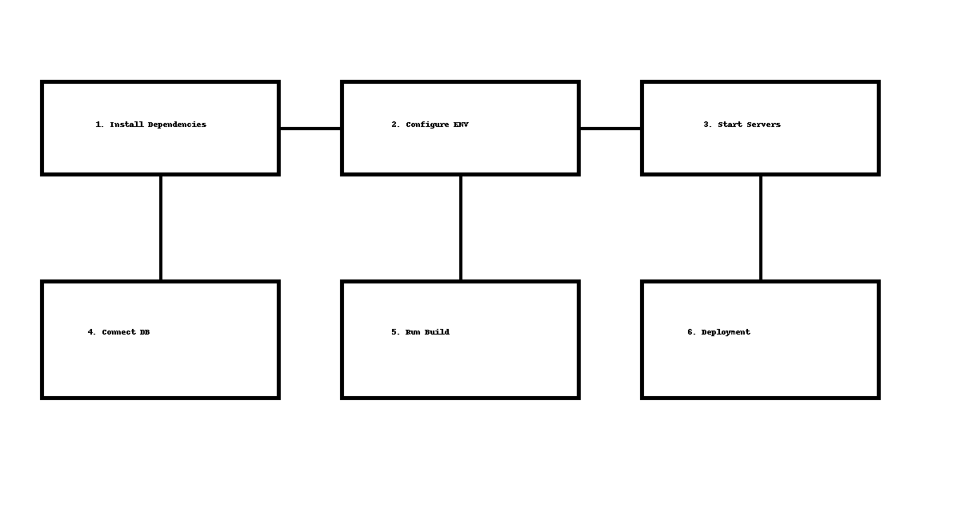
---
## 10. Troubleshooting & Notes (Professional Level)
• If dependencies fail – delete node_modules and reinstall
• If MongoDB does not connect – verify IP access + connection string
• If CORS error appears – update allowed origins in backend
• For slow builds – enable production flags and caching
• For backend crashes – inspect logs using PM2 or Docker logs
---
## 11. Conclusion
This Setup Guide provides a fully comprehensive, enterprise-standard procedure for installing, configuring, and deploying
the system in any environment. The instructions ensure reliability, security, and scalability — making the application
ready for MNC presentation, production rollout, or engineering evaluation.
This concludes **Topic 4: Setup Instructions**.

